exp5)-BETWEEN,IN,AGG FUNCTIONS;

1)between:

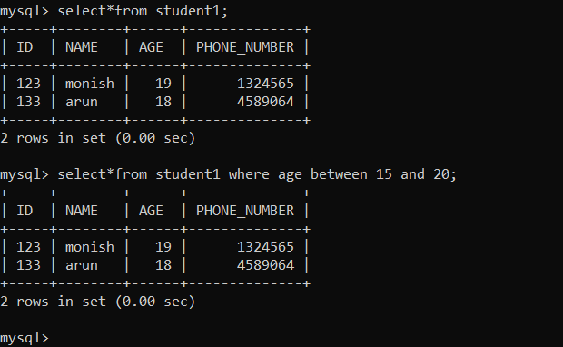

2)IN:

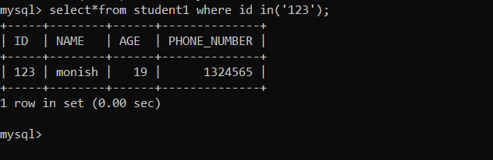

3)AGG FUNCTIONS;

